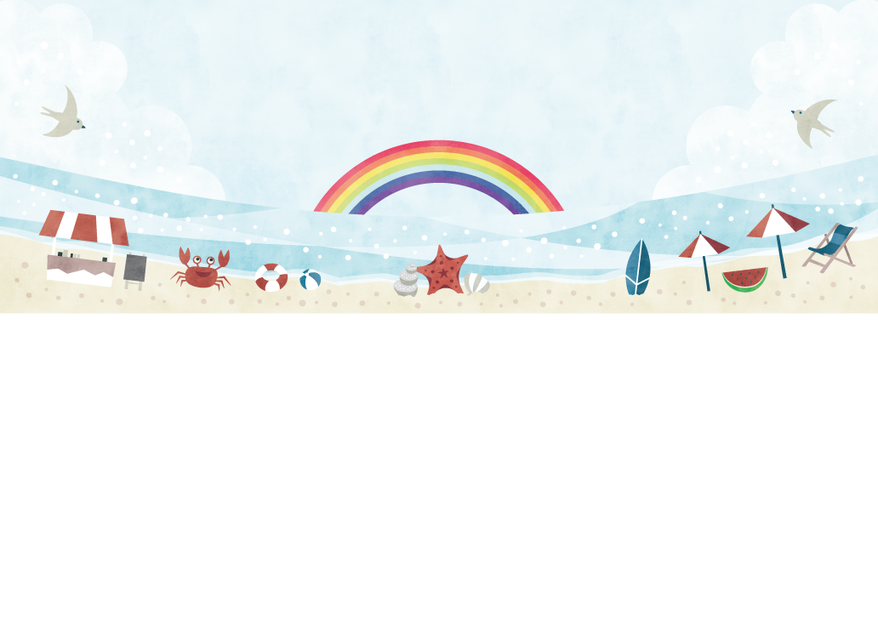
Memories of Summer Vacation
夏休みの思い出
暑假的回憶

Let’s write and talk about the summer vacation!

 | Remember your summer vacation. What did you do? | THINK

went to Osaka / visited Japan / visited my grandmother / had a trip (to Tokyo)
swam in the sea / swam in the river / played on the beach / went fishing / caught fish
caught insects / went shopping / bought many things / slept a lot / took a nap
cooked for my family / enjoyed the hot spring / ate sushi / made a pumpkin cake
had a barbecue party / got a girl friend / got a boy friend / studied English
went to the library / read many books / saw movies / saw Harry Potter / went camping

 | Write about your summer memories. | WRITE

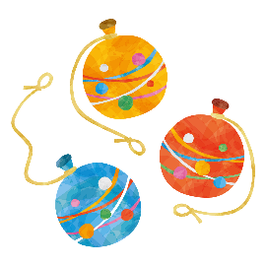

 | Tell your friends about your summer memories. | SPEAK

Please feel free to write your comment. 活動の感想を書きましょう。寫下您的印象。
 | 年 | 組 | 番
 | 名 前
(C) わくわく教材ランド <www.e-kyozai.com>

