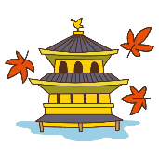
修学旅行の思い出 ベスト４発表!
Let’s write and talk about our school trip!
4 Best Memories!

修学旅行でのいろいろな思い出。とっておきの思い出を教えてください！

 | Remember your school trip. What did you do? | THINK
◆訪れた場所や泊まった宿について書こう
We visited Kyoto. （私たちは京都を訪れました。）／We stayed in ABC hotel. （私たちはABCホテルに泊まりました。）

◆食べたものについて書こう
I ate sukiyaki.（私はすき焼きを食べました。）／I had some dumplings at Kinkakuji.（金閣寺でお団子を食べました。）

◆買ったものについて書こう
I bought a bag for my brother. （弟にカバンを買いました。）／I bought a wooden sword.（私は木刀を買いました。）

◆見たものについて書こう
I saw a very big temple.（私はとても大きなお寺を見ました。）／We saw a beautiful view.（美しい景色を見ました。）

◆感動したこと、驚いたことについて書こう
Dinner moved me.（私は夕食に感動しました。）／I was surprised at the size.（私はその大きさに驚きました。）

 | Write about your school trip. | WRITE

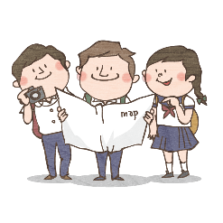

 | Tell your friends about your school trip. | SPEAK

Please feel free to write your comment. 活動の感想を書きましょう。
 | 年 | 組 | 番
 | 名 前
(C) わくわく教材ランド <www.e-kyozai.com>

