「私が新年にやりたい８つのこと」 |  |  | どんな年にしたいかを漢字１字で！
NAME |  |  | Kanji representing  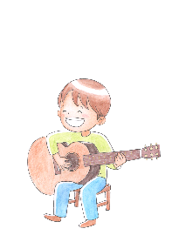  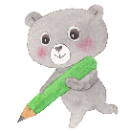  the new year for me
FOOD I want to cook or eat |  | MUSIC I want to enjoy
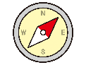  CITY I want to visit  □Asia □Africa □North America  □South America □Europe □Oceania  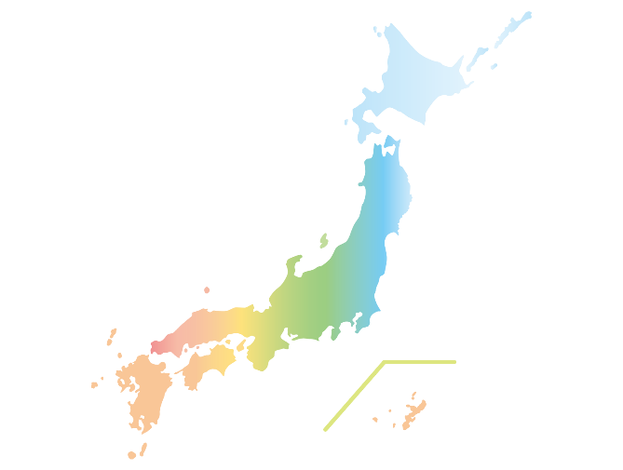  CITY  NAME |  | SUBJECT I want to study hard
My new year’s GOAL
What do you want to try?

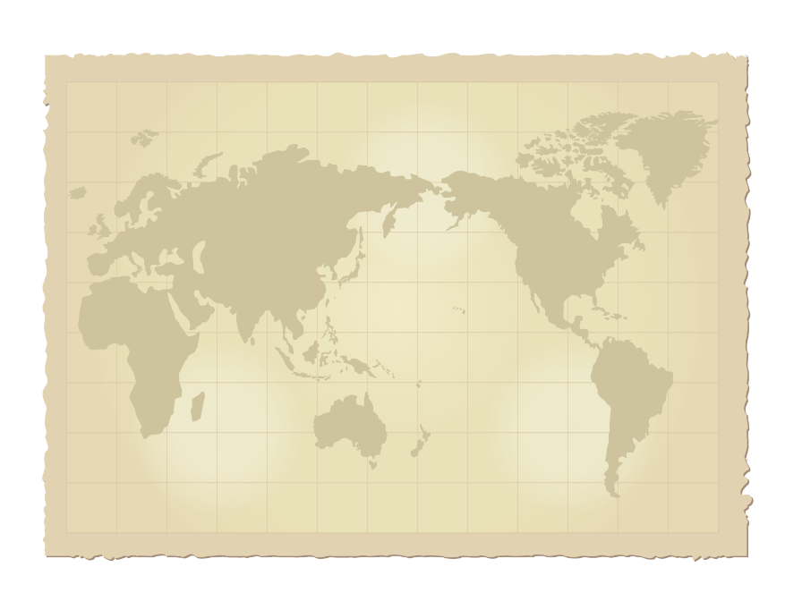
Put a red star on the place.
BOOK I want to read
Number  of new friends I want | What I want to do for everyone’s earth
Wakuwaku Kyozai Land <www.e-kyozai.com>

